Advanced Python Pacing Guide

# Course Overview

In this Python training course, students already familiar with Python programming will learn advanced Python techniques.

This advanced Python course is taught using Python 3; however, differences between Python 2 and Python 3 are noted. For private Python classes, our instructor can focus specifically on Python 2 if desired.

# Class Goals

* Learn to work with IPython Notebook.
* Learn to work with the Collections module.
* Learn about mapping and filtering and lambda functions.
* Learn advanced sorting.
* Learn to work with regular expressions in Python.
* Learn to work with databases, CSV files, JSON, and XML.
* Learn to write object-oriented code in Python.
* Learn to test and debug your Python code.
* Learn about Unicode and text encoding.

# Class Prerequisites

Experience in the following areas is required:

* Basic Python programming experience. In particular, you should be very comfortable with:
  1. Working with strings.
  2. Working with lists, tuples and dictionaries.
  3. Loops and conditionals.
  4. Writing your own functions.
* Some exposure to HTML, XML, JSON, and SQL.

# Pacing

This is a 3-day course. Day 1 should cover lessons 1-3, Day 2 lessons 4 and 5, and Day 3 lessons 6 and 7. The estimated time for each exercise is given in the course manual as in the example below:   
  
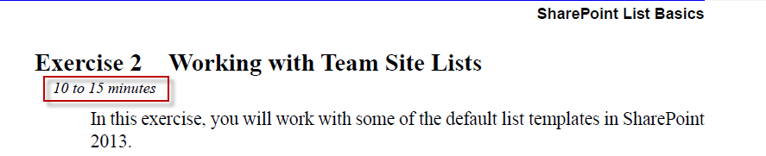

# Feedback

We strive to keep our courses up to date and error free. You can send feedback to Donna Lysak, Director of Courseware at [courseware@webucator.com](mailto:courseware@webucator.com). Thank you.